What separates the Fan Girl (soon to be named) from the other characters is that the her mechanics allow her to directly interact with the level design; the FanGirluses her gigantic fan to move around objects and landscapes.

The Fan Girl uses a fan, obviously. The fan is bigger than the Fan Girl’s body (as seen in Figure 1). She uses this fan to create gust of wind which can be used to move objects such as platforms into more advantageous positions. Also, Fan Girl can use the fan as a glider by riding it and using any gust of wind to gain more airtime.

Concept art:The Fan Girl will be around the age of 10 and will have an art style centric to the Japanese culture we’ve structured the other character designs from. Her shoes will Japanese wooden sandals (they’re called Getas (TBD)) In the future, Capri will post concept art for us, but as of now this is what we have to go off of.

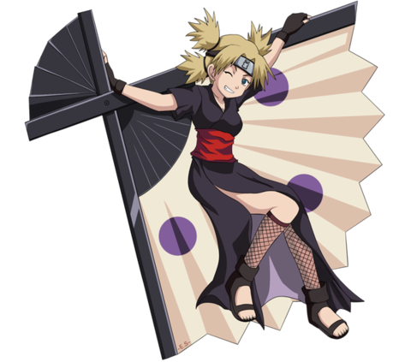Figure 1

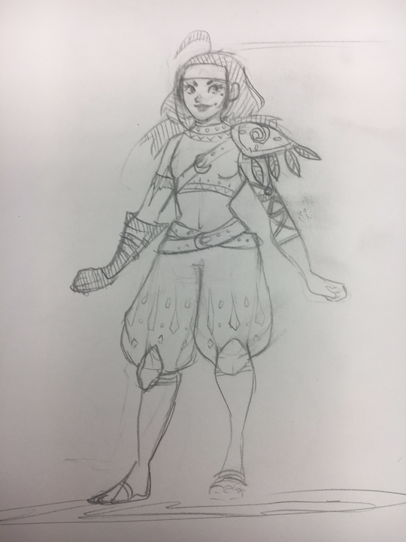

Concept Art #1

The mechanics of the Fan Girl include the following:

Free Mechanic: Ability to create upwards draft (basically allows for the person to move upwards), *see gif for a similar presentation of mechanic*: <http://gph.is/2h4N1fQ>

First Mechanic: Fan Glider

Second Mechanic: Ability to move objects using the fan

Third Mechanic: Taunt (TBD)